MEDICAL INVENTORY MANAGEMENT

**College Name : CHIKKANNA GOVERNMENT ARTS COLLEGE College Code : BRU06**

**Team ID : NM2025TMID26263**

**Team Size : 4**

**Team Leader : DHANABALAN G**

**Team member : AATHISHKUMAR M**

**Team member : LAKSHMANAN V**

**Team member : SIVAN V**

# Project overview :

## 1.Introduction :

The Medical Inventory Management System project aims to design and implement a streamlined solution for tracking, managing, and optimizing the use of medical supplies and equipment within a healthcare facility. The project addresses the critical need for accurate inventory control to ensure the continuous availability of essential medical items, reduce waste, and support efficient healthcare delivery.

This system will enable healthcare staff to monitor inventory levels in real-time, automate reordering processes, track expiration dates, and generate reports for better decision-making. By integrating digital tools such as barcoding, RFID, and inventory management software, the project will minimize human errors, reduce operational costs, and improve compliance with regulatory standards.

The system is intended to serve hospitals, clinics, pharmacies, and laboratories, providing an adaptable and user-friendly platform that supports daily operations and long-term inventory planning.

## Milestone 1-Salesforce Account :

### Activity 1: Creating Developer Account

Creating a developer org in salesforce.

1. Go to <https://developer.salesforce.com/signup>
2. On the sign up form, enter the following details :

[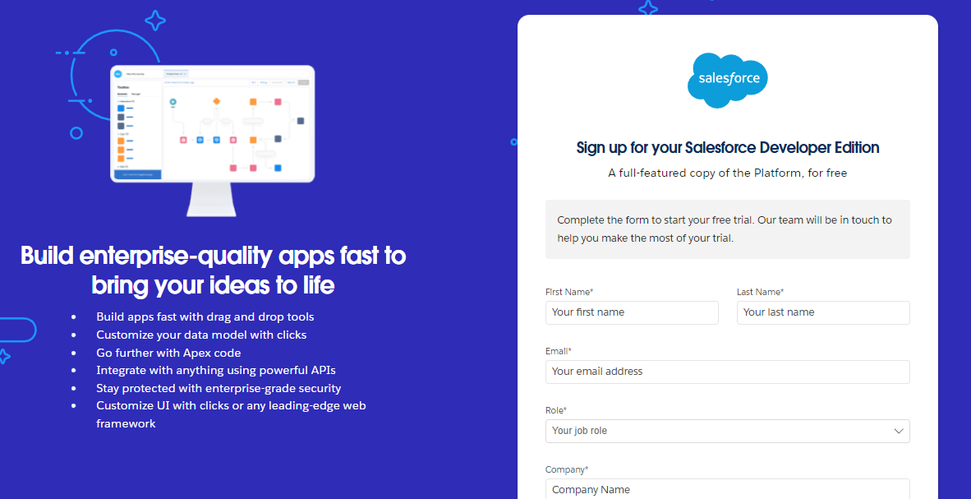](https://developers.salesforce.com/Signup*)

1. First name & Last name
2. Email
3. Role : Developer
4. Company : College Name
5. County : India
6. Postal Code : pin code
7. Username : should be a combination of your name and company

This need not be an actual email id, you can give anything in the format : username@organization.com

Click on sign me up after filling these.

### Activity 2: Account Activation

1. Go to the inbox of the email that you used while signing up. Click on the verify account to activate your account. The email may take 5-10mins.

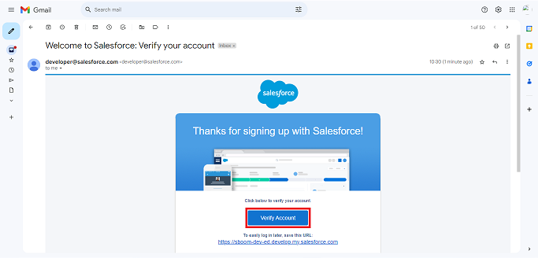

1.Click on Verify Account

2.Give a password and answer a security question and click on change password.



3.Then you will redirect to your salesforce setup page.



## Milestone 2- Objects

### Creating a Product Object

*To create an object: Product,Purchase Order, Order Item, Inventory Transaction and Supplier objects.

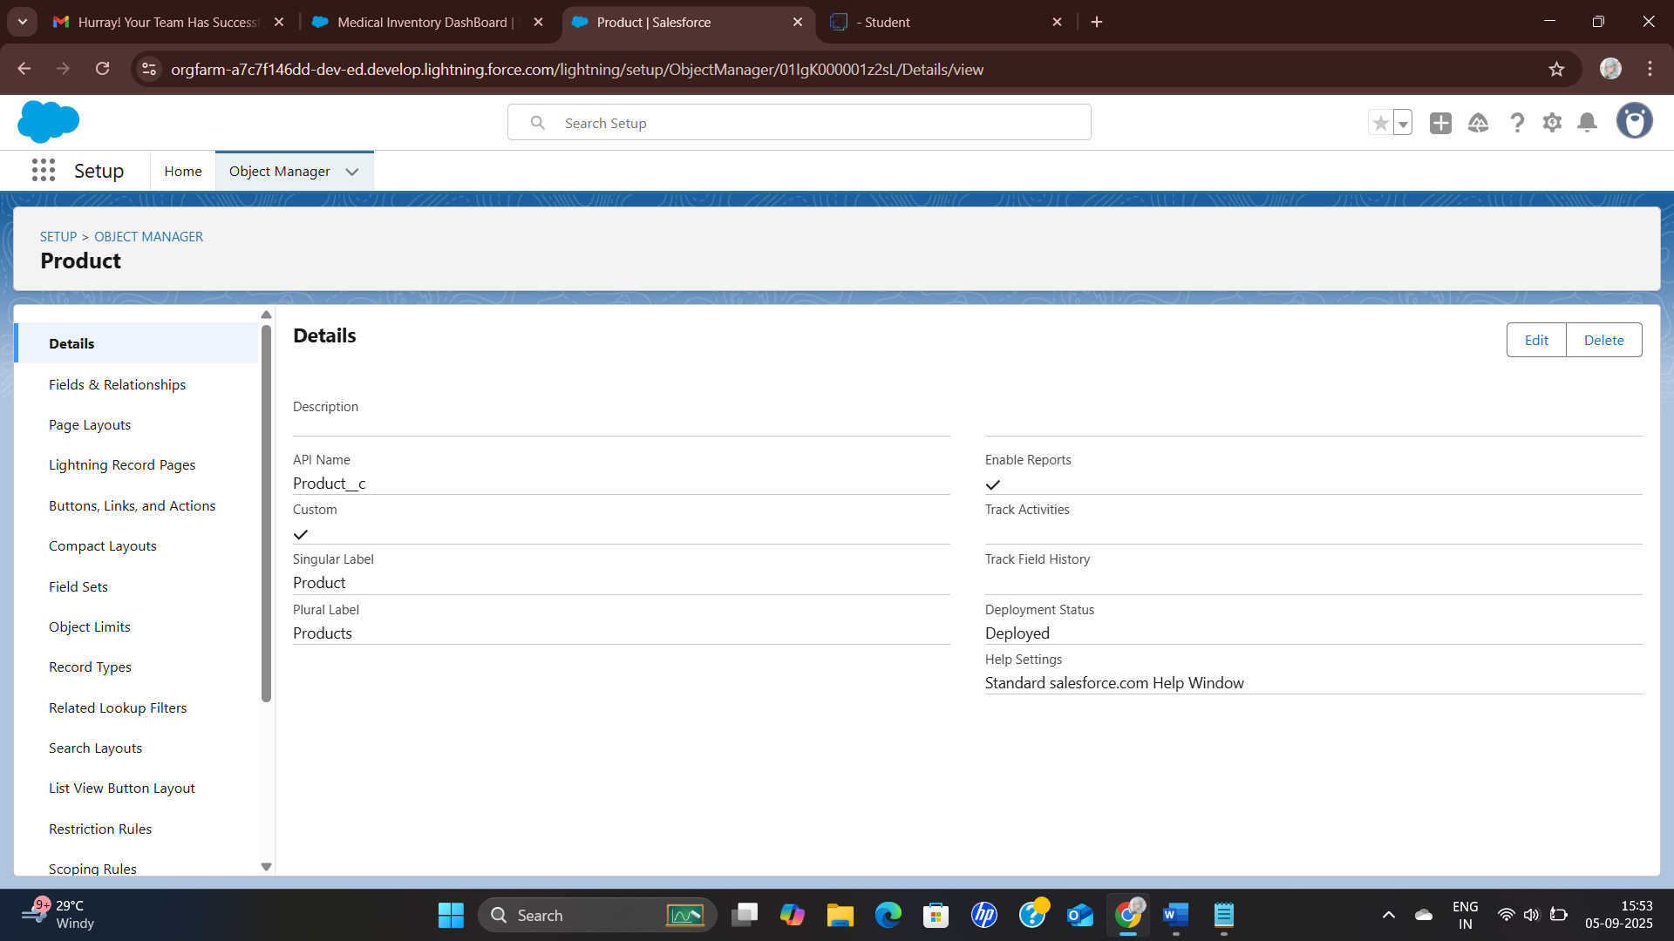

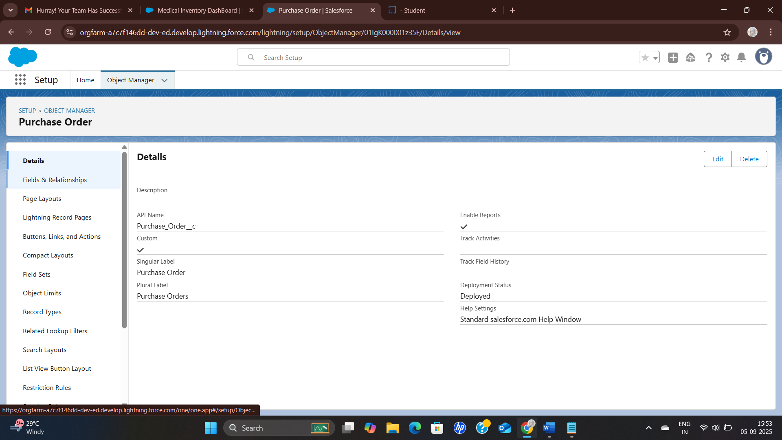

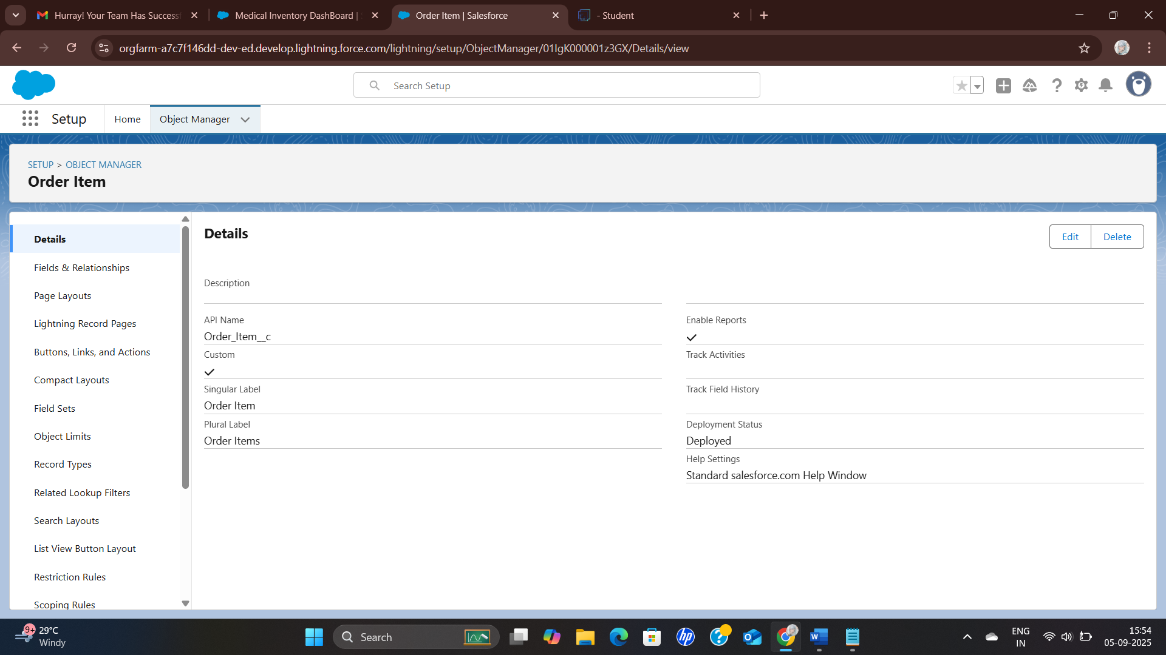

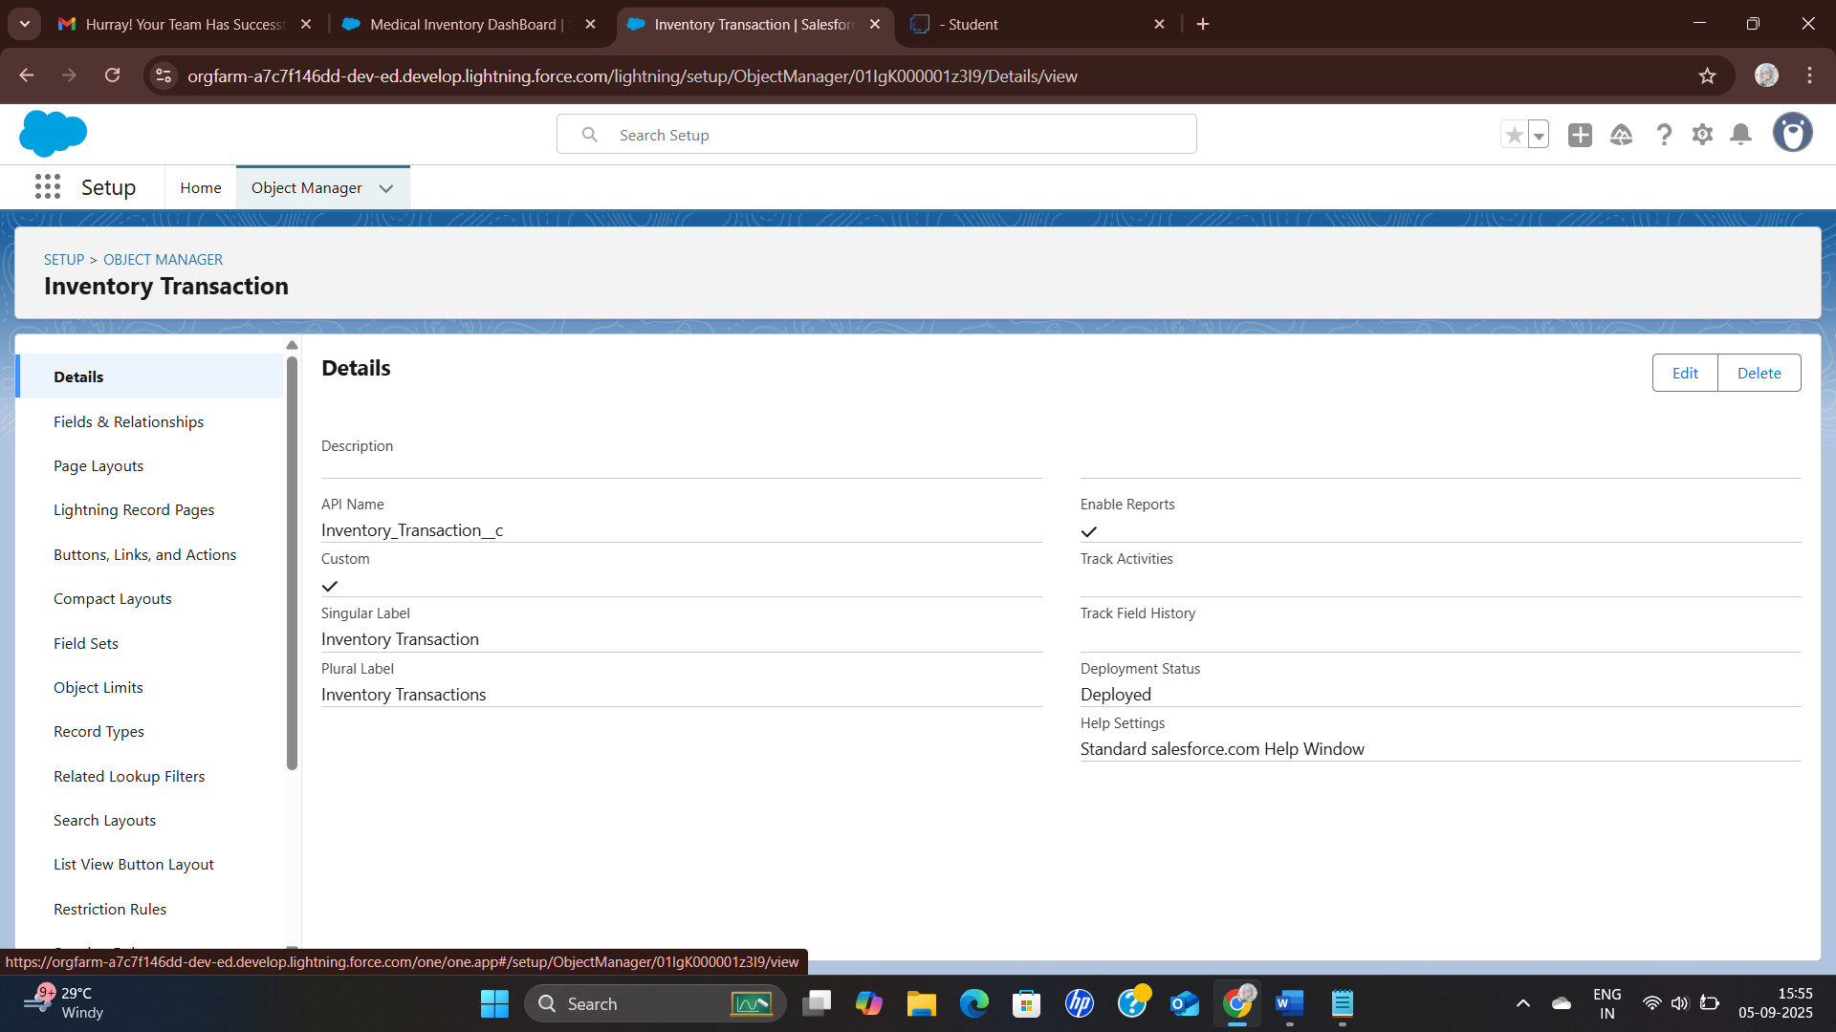

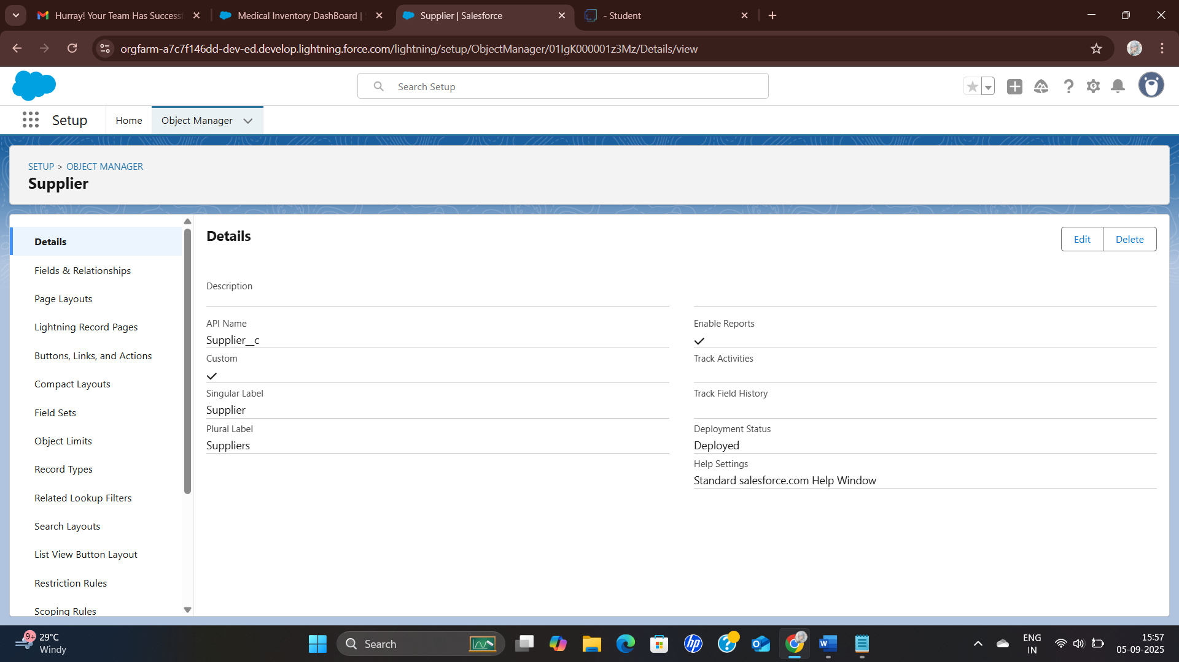

## **Milestone 3- Tabs**

### Creating a tab for Product Object

*Create a tab for Product,Purchase Order, Order Item, Inventory Transaction and Supplier objects.

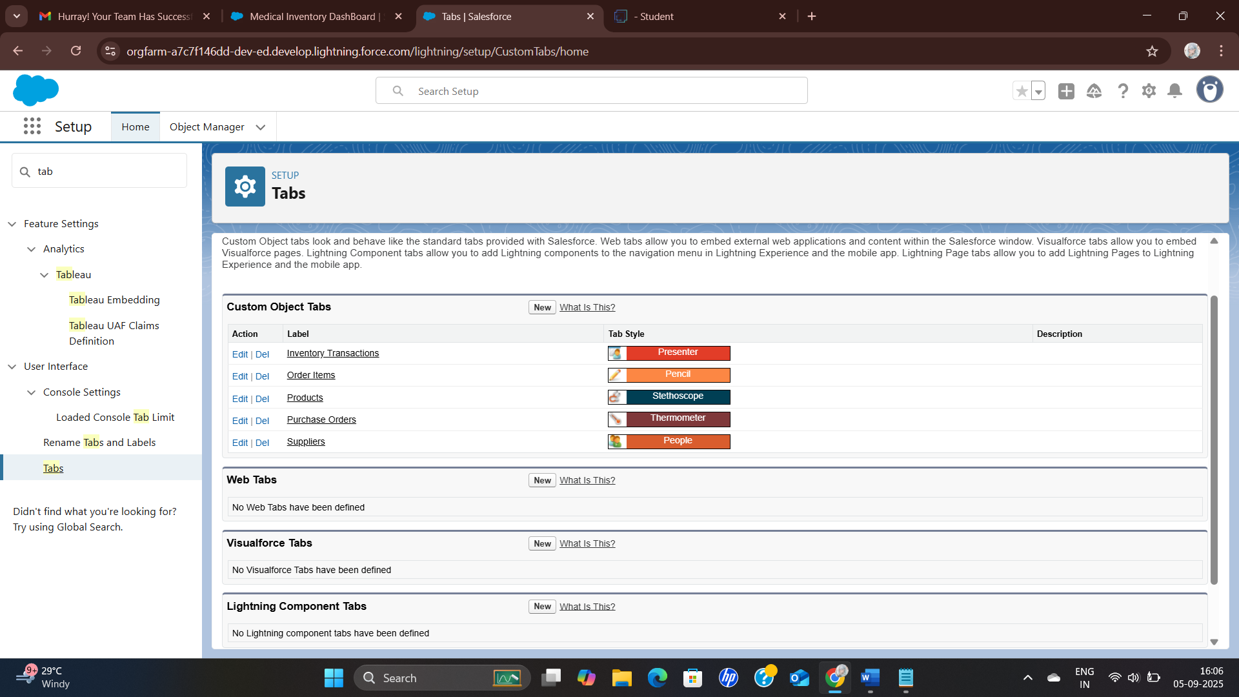

## Milestone 4- The Lightning App

### Create a Lightning App for Medical Inventory Management

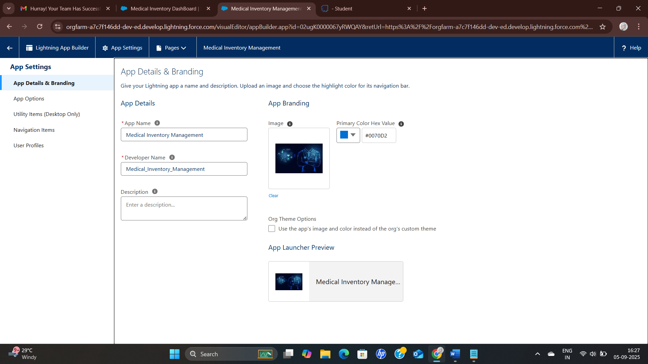

## Milestone 5- Fields

### Create a fields

*Create a field for Product,Purchase Order, Order Item, Inventory Transaction and Supplier objects.

|  |  |  |
| --- | --- | --- |
| **Object** | **Field Name** | **Data Type** |
| **Product** | Product ID(Standard) | Text |
|  | Product Name | Text |
|  | Product Description | Text Area |
|  | Minimum Stock Level | Number(18, 0) |
|  | Current Stock Level | Number(18, 0) |
|  | Unit Price | Currency(16, 2) |
|  | Expiry Date | Date |
| **Purchase Order** | Purchase Order ID(Standard) | Text |
|  | Supplier ID | Lookup(Supplier) |
|  | Order Date | Date |
|  | Expected Delivery Date | Date |
|  | Actual Delivery Date | Date |
|  | Order Count | Roll-Up Summary (COUNT Order Item) |
|  | Total Order Cost | Currency(16, 2) |
| **Order Item** | Order Item ID(Standard) | Text |
|  | Product ID | Lookup(Product) |
|  | Purchase Order ID | Master-Detail(Purchase Order) |
|  | Quantity Ordered | Number(18, 0) |
|  | Quantity Received | Number(18, 0) |
|  | Unit Price | Formula(Currency) |
|  | Amount | Formula(Currency) |
| **Inventory Transaction** | Transaction ID(Standard) | Text |
|  | Purchase Order ID | Lookup(Purchase Order) |
|  | Transaction Date | Date |
|  | Transaction Type | Picklist |
|  | Total Order Cost | Formula(Currency) |
| **Supplier** | Supplier ID(Standard) | Text |
|  | Supplier Name | Text |
|  | Contact Person | Text |
|  | Phone Number | Phone |
|  | Email | Email |
|  | Address | TextArea |

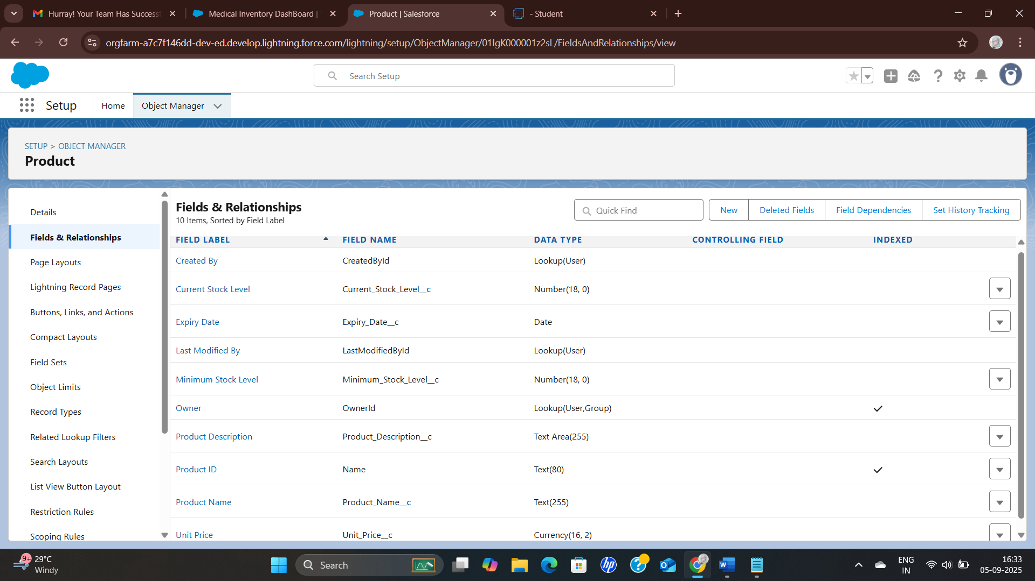

 *The same way to create the another (Purchase Order, Order Item, Inventory Transaction and Supplier) field objects.

## Milestone 6 -Editing of Page Layouts

### To edit a Page Layout

*To edit a Page Layout in Product,Purchase Order, Order Item, Inventory Transaction and Supplier objects.

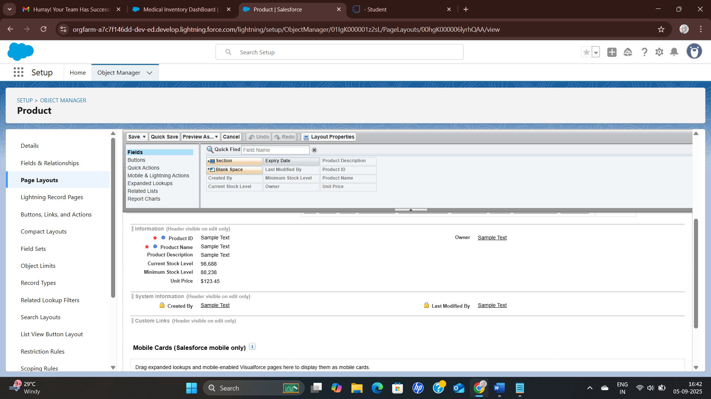

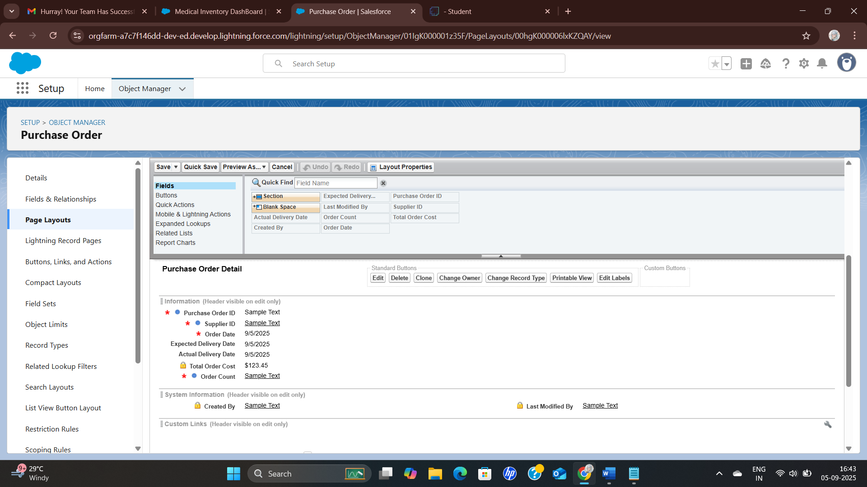

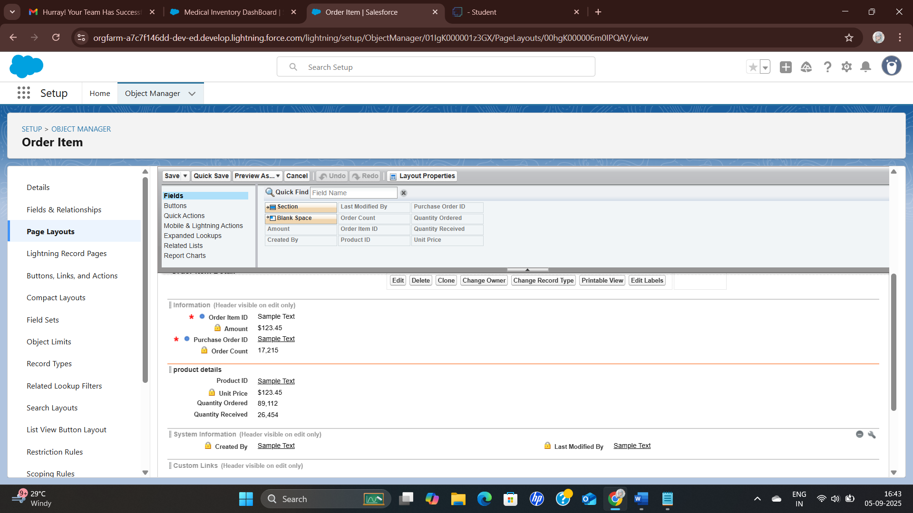

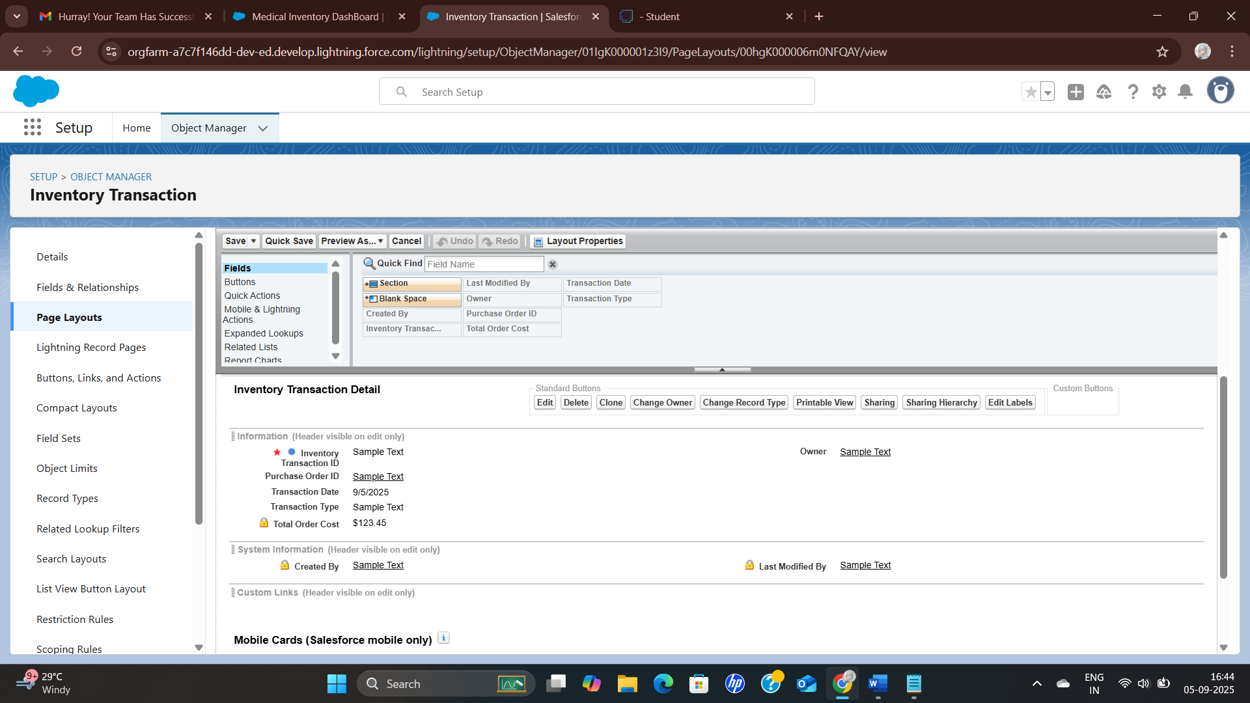

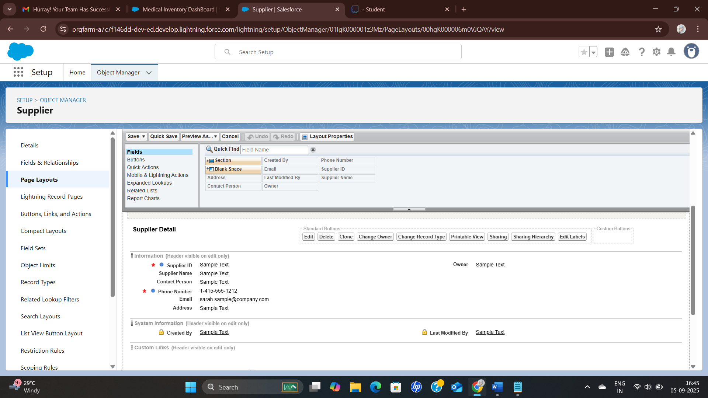

## Milestone 7 - Compact Layouts

### To create a Compact Layout

*To create a Compact Layout to a product and purchase order objects.

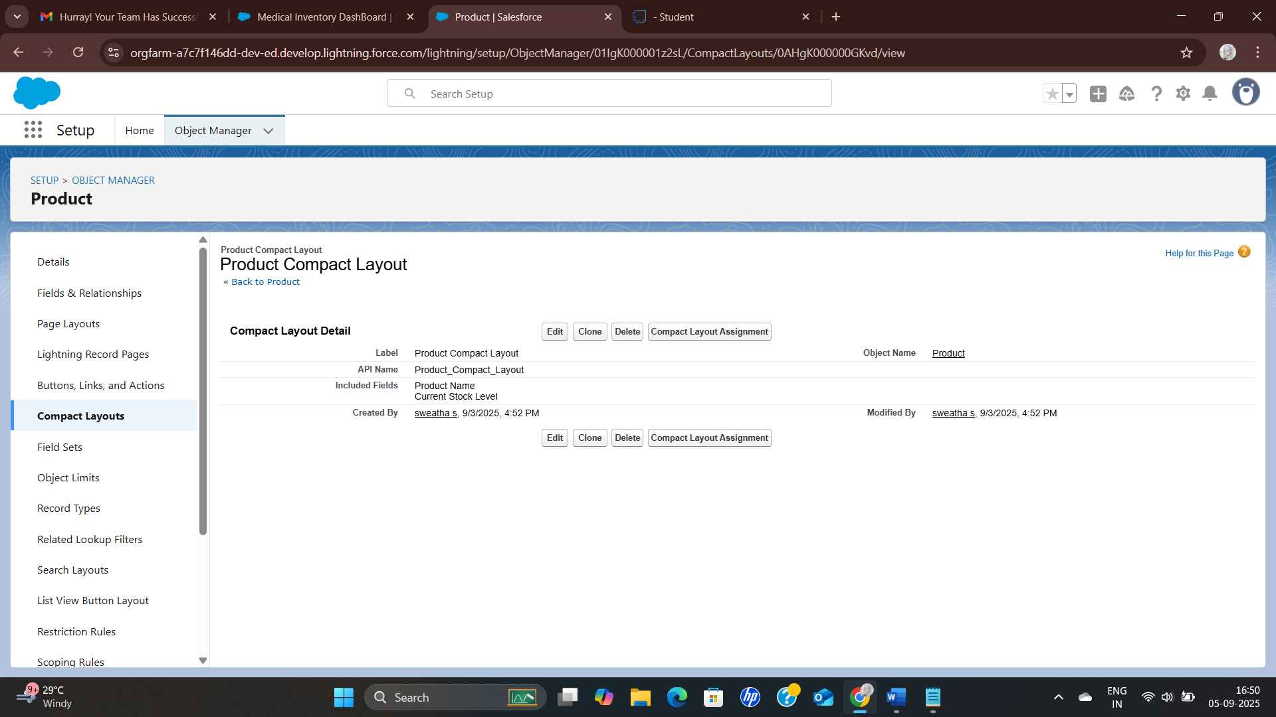

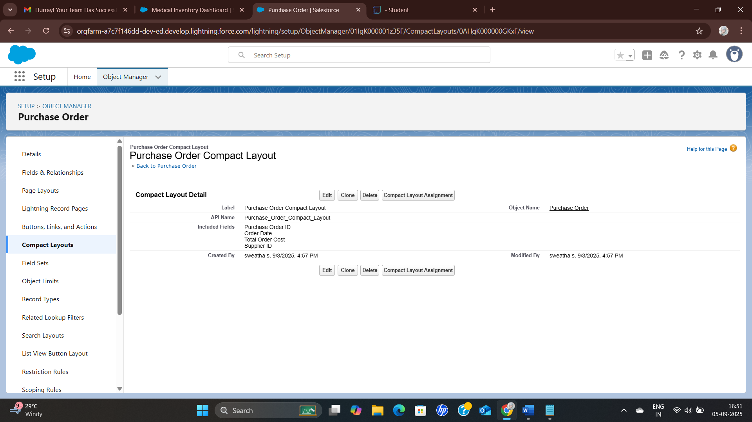

## Milestone 8 - Validation Rules

**\*To create an Expected Delivery Date Validation rule to a Employee Object**

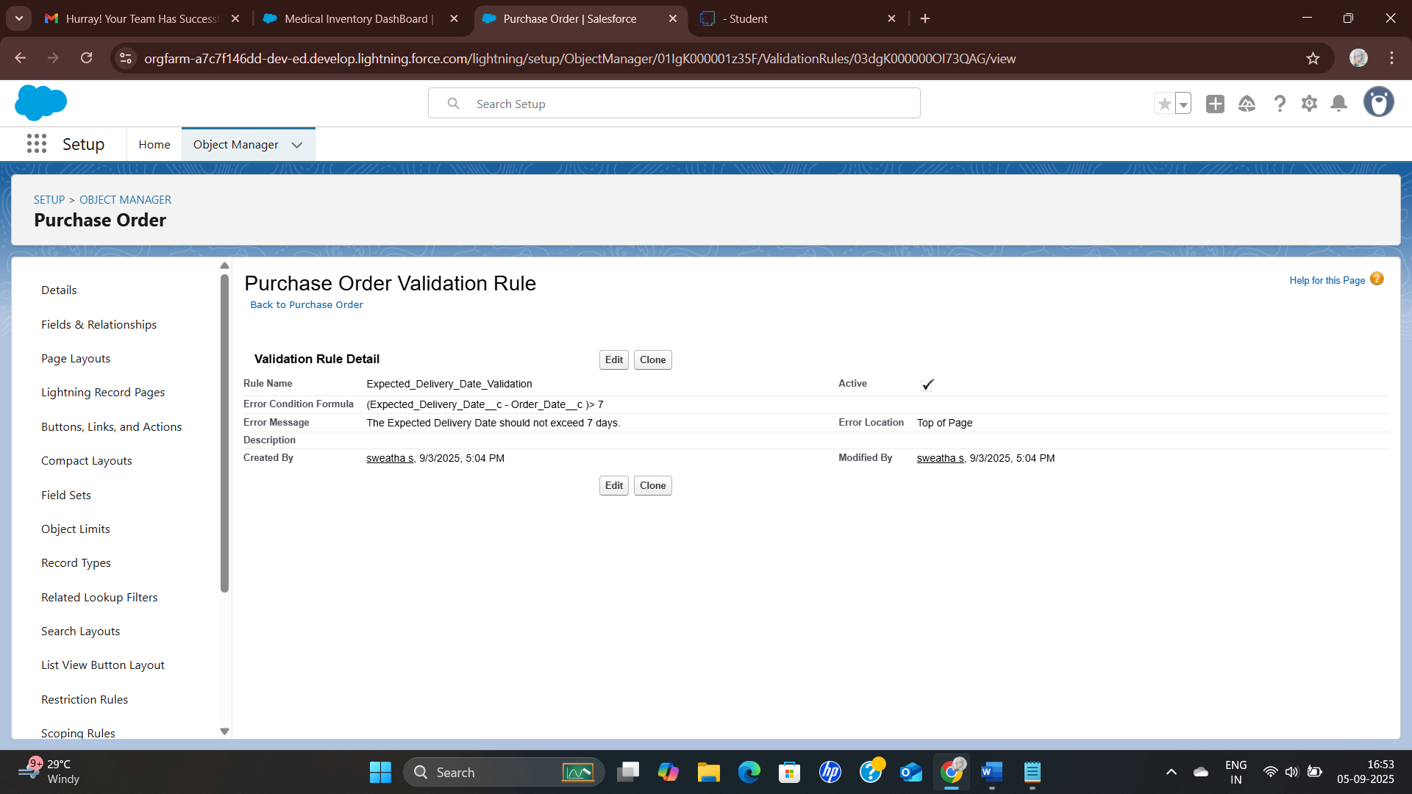

## Milestone 9 – Profiles

### To create Profiles

*To create a Inventory Manager and Purchase Manager profiles.

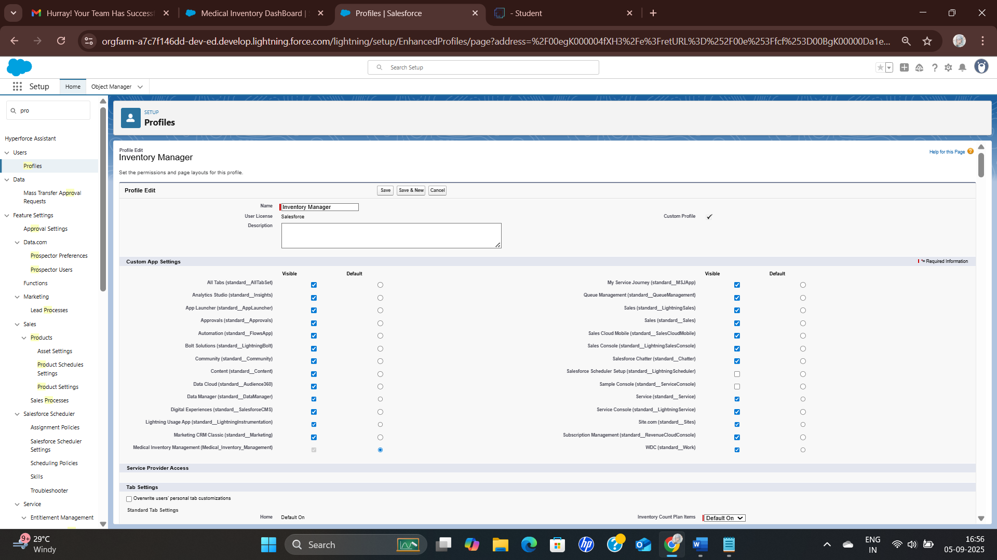

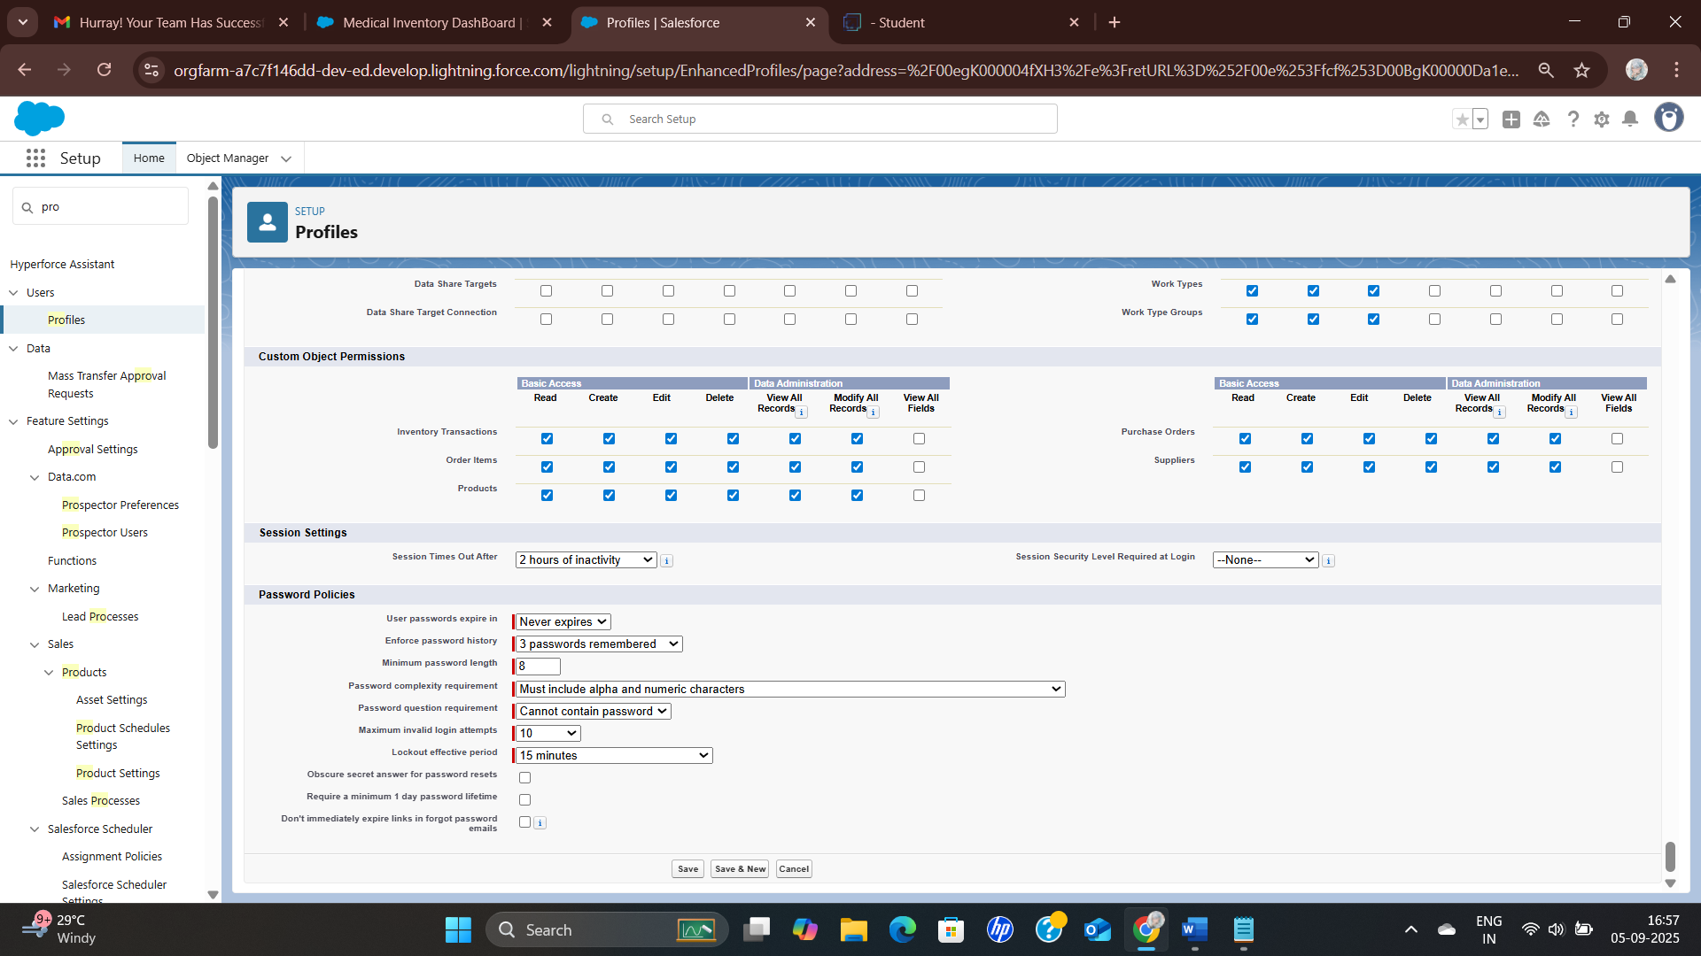

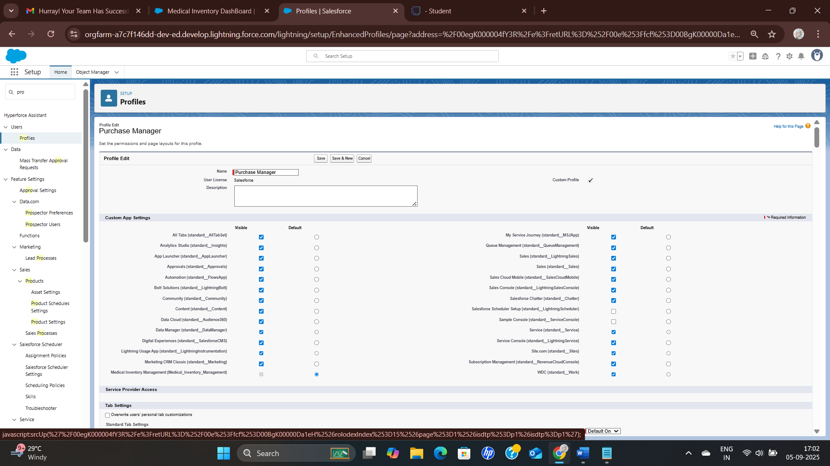

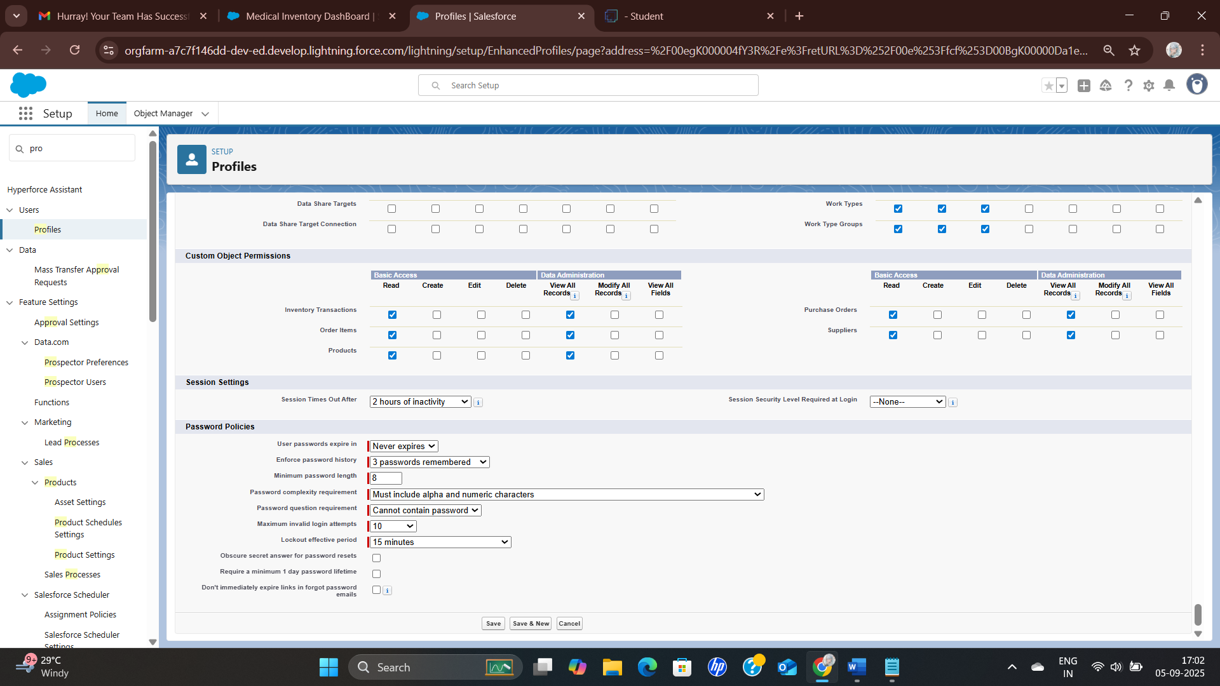

## Milestone 10 - Roles

### Create a Roles

*Create a roles for Purchasing Manager and Inventory Manager.

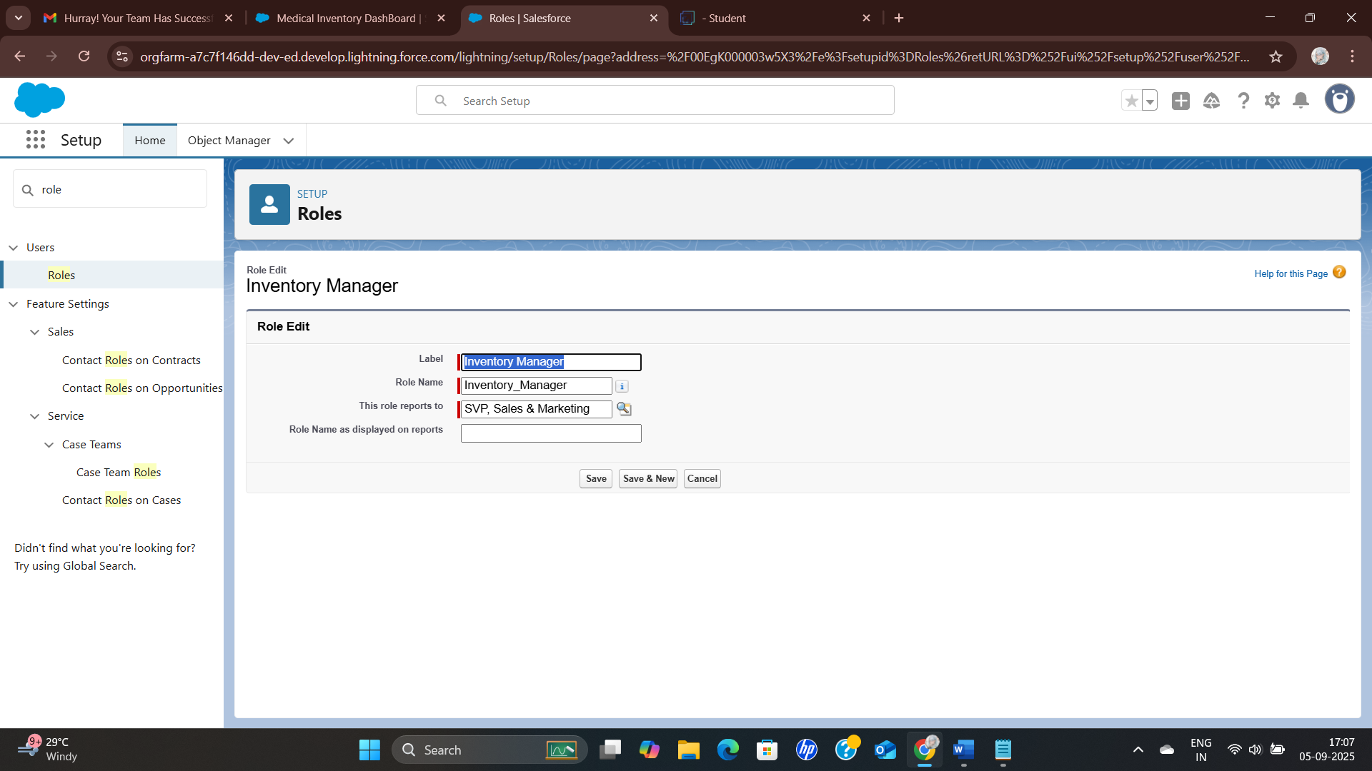

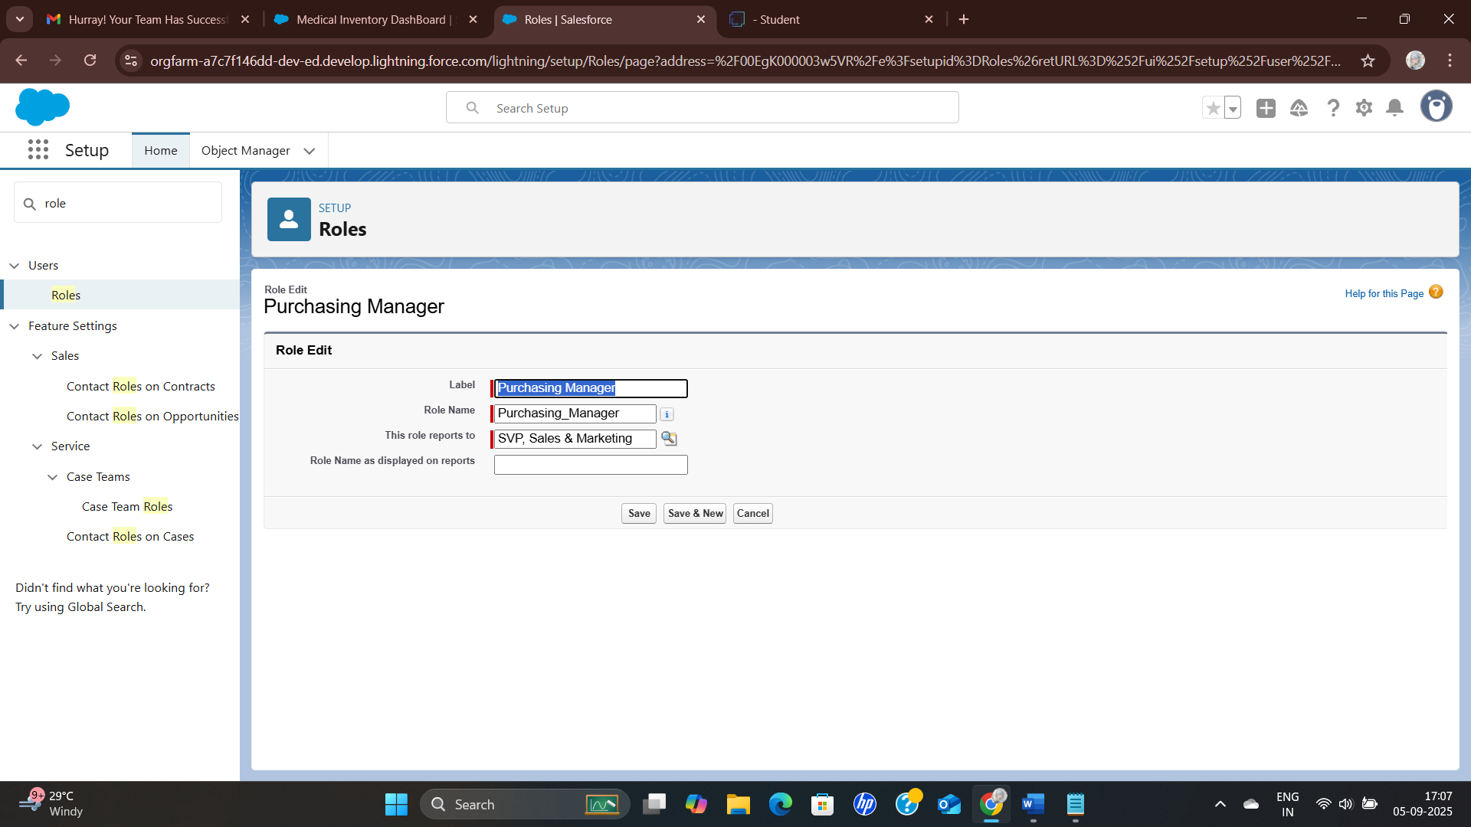

## Milestone 12 - Permission Sets

### Create a Permission Set

*Create a Purchase Manager Create Access to permission sets.

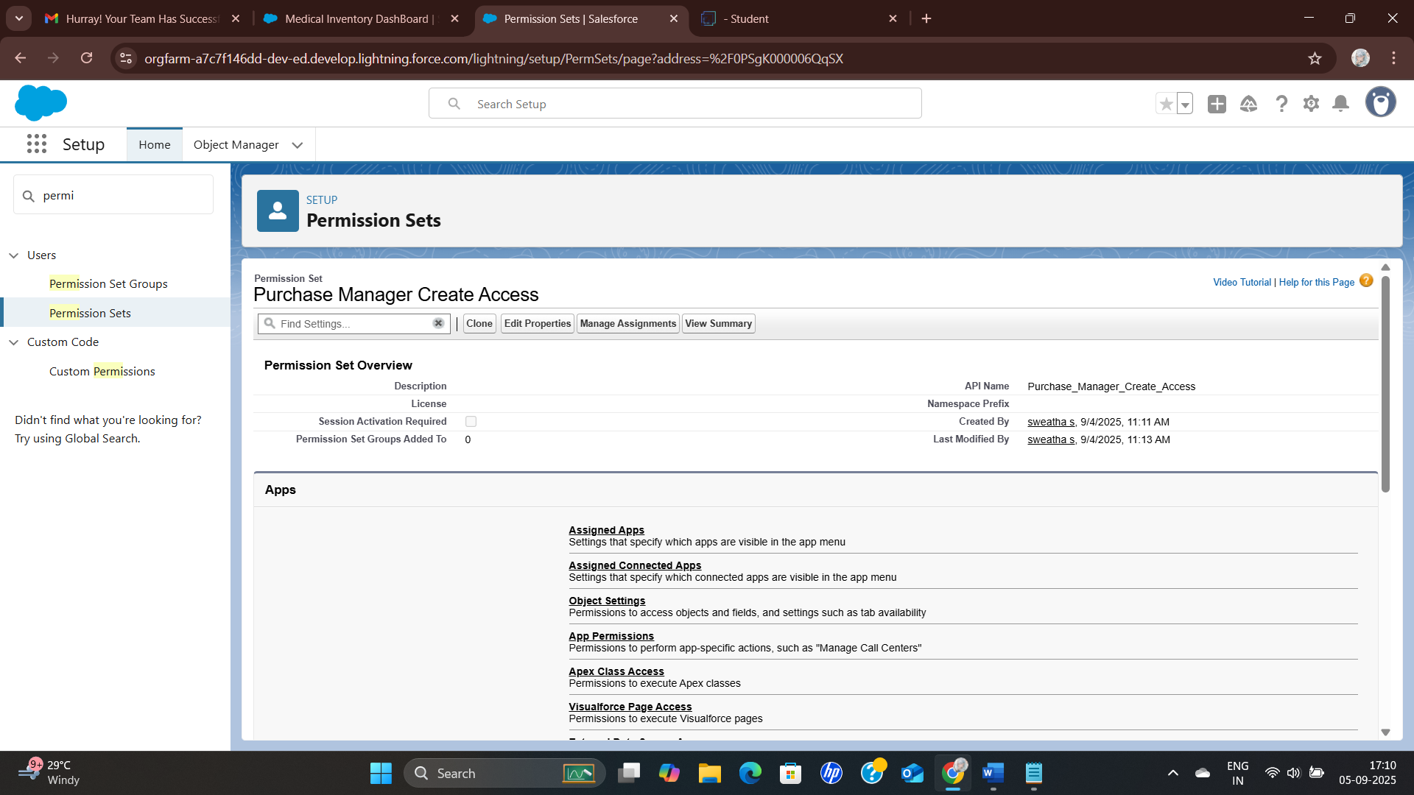

## Milestone 13 – Flows

**\*Create Flow to update the Actual Delivery Date.**

1. Go to setup >> type Flow in quick find box >> Click on the Flow and Select the New Flow >> Start From Scratch .

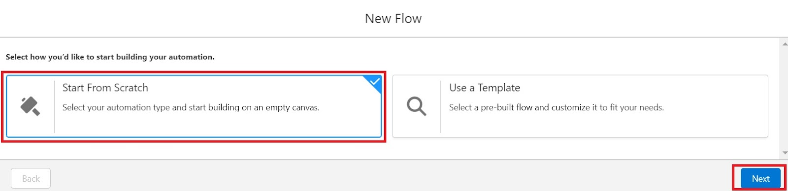

1. Select the record Triggered flow.Click on create.

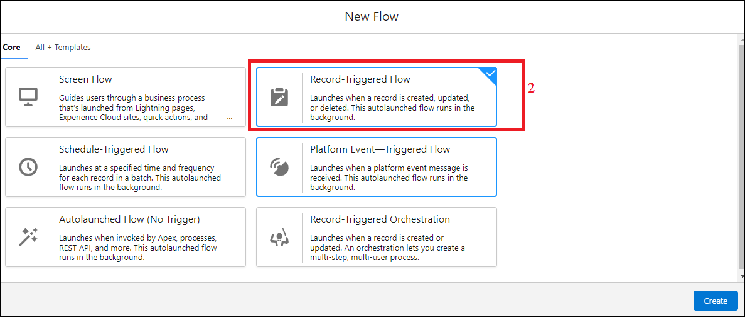

1. Under Object select “Purchase Order”
2. Select  A record is created or updated

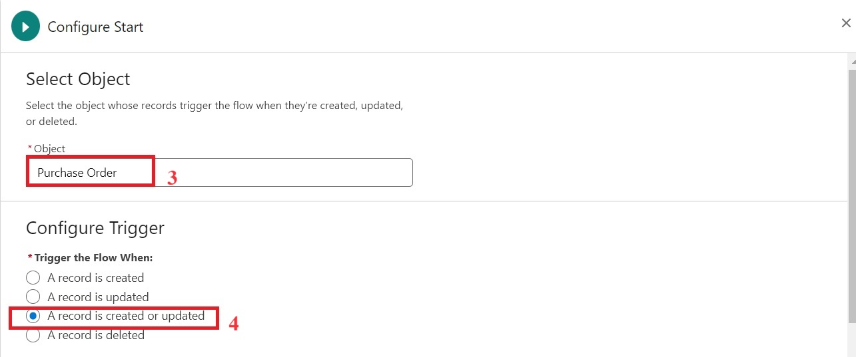

1. Set Entry Conditions : None
2. Select Fast Field Updates and click on Done

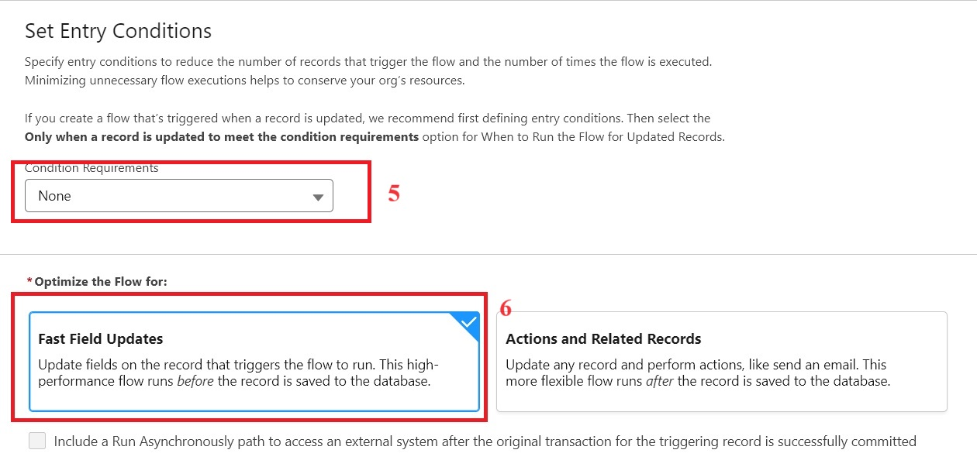

1. Under the record trigger flow click on the “+” icon and select Get Records.
2. Enter Label as “ Get Purchase Record ”.
3. For Object select Purchase Order.
4. For Condition Requirements , select All Conditions are Met(AND)

        For the first condition select as follows:

                                 Field: Id

                                 Operator: Equals

                          Value: {!$Record.Id}

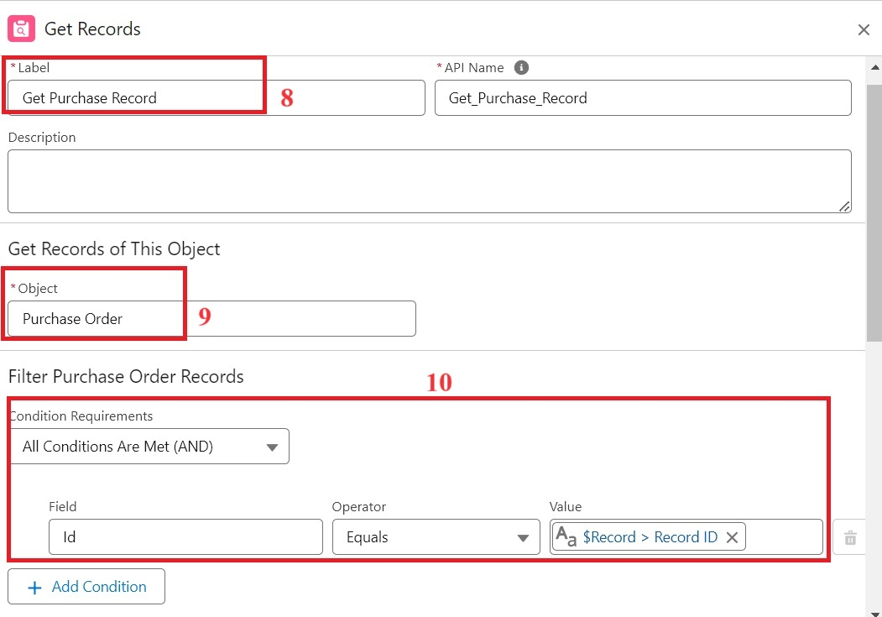

1. For How many Records to store Select Only the First Record.
2. For How to Store Record Data select Choose fields and let Salesforce do the rest. Select Field: Order_Date__c.  Click on Done.

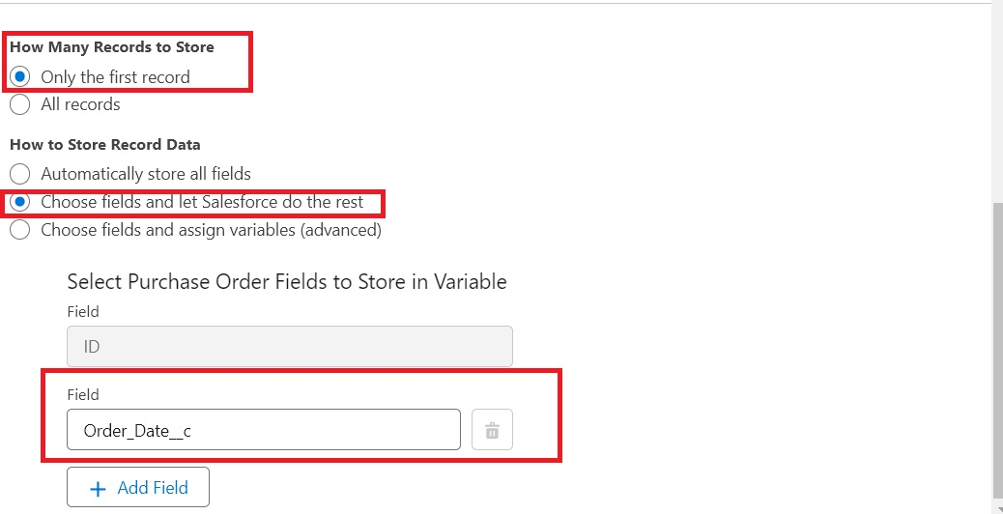

1. In the Flow Builder, click on the Manager tab on the left-hand side >> Click on New Resource >> In the Resource Type dropdown, select Variable.
2. Enter API name as ActualDeliveryDate >> Select Data type as Date >> Click on Done.
3. From the Toolbox drag and drop Assignment element.
4. Enter the label as “Assignment”.
5. Set Variable Values:

               a)  Variable : {!ActualDeliveryDate}

                     Operator : Equals

                      Value : {!$Record.Order_Date__c}

               b)  Variable : {!ActualDeliveryDate}

                     Operator : Add

                      Value : 3

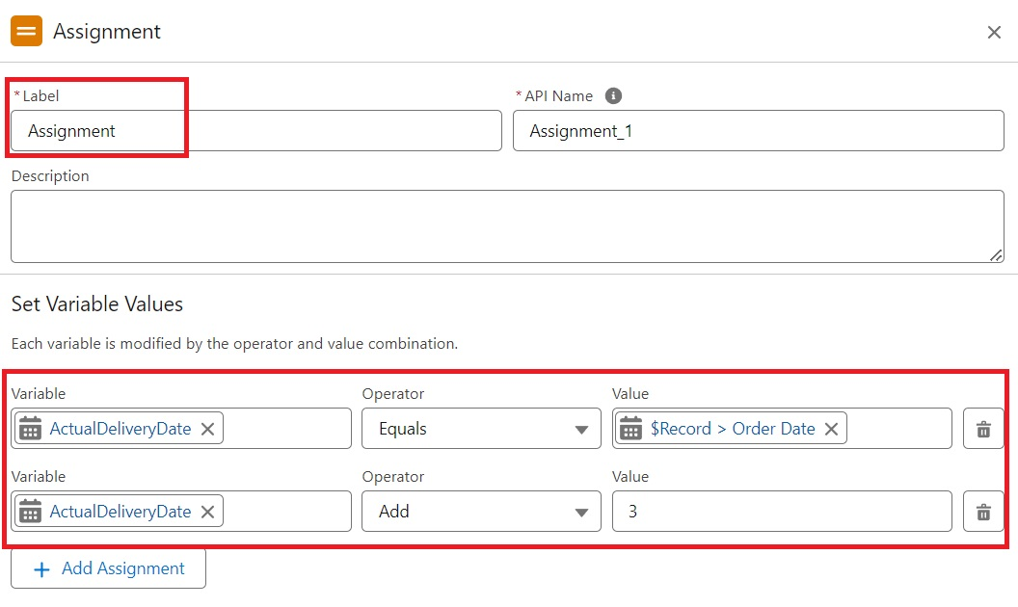

1. Click Done
2. From the Toolbox drag and drop Update Records element and connect to the Assignment element.
3. Enter the label as “Updating Purchasing Order”.
4. How to Find Records to Update and Set Their Values : Use the Purchase Order record that triggered the flow
5. Set Filter Conditions : None -Always Update Record
6. Set Field Values for the Trip Record as

 Field :  Actual_Delivery_Date__c

 Value : {!ActualDeliveryDate}

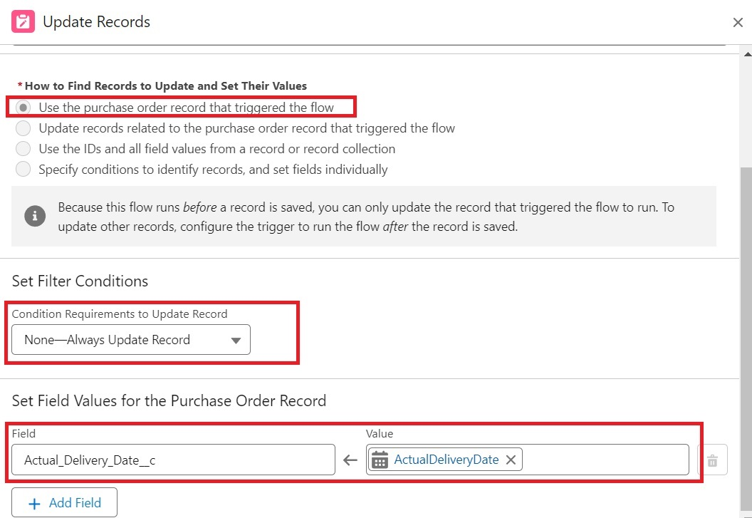

1. Click Done
2. Save the flow as “Actual Delivery Date Updating”.
3. Activate the flow.

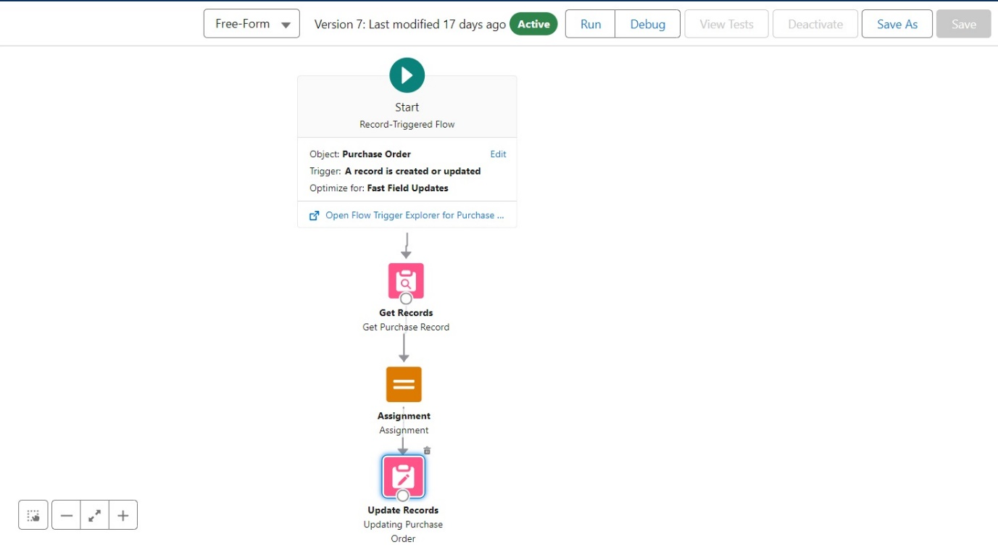

## Milestone 14 - Triggers

### Create a Trigger to Calculate total amount on Order Item

Step 1 : Login to Salesforce:

Log in to your Salesforce account with administrative privileges.

Step 2:

i)Navigate to Setup: Once logged in, click on the gear icon ?? (Setup) located at the top-right corner of the page. This will open the Setup menu.

ii)Click on Developer Console: Click on the "Developer Console" option from the Setup menu.   This will open the Developer Console in a new browser tab or window.

Step 3:

i) In the Developer Console window, go to the top menu and click on "File".

ii)Select New: From the dropdown menu under "File", select "New".

iii)Choose Apex Trigger: This will open a new Apex Trigger editor tab.

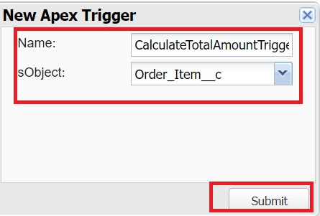

Create an Apex Trigger:

trigger CalculateTotalAmountTrigger on Order_Item__c (after insert, after update, after delete, after undelete) {

    // Call the handler class to handle the logic

    CalculateTotalAmountHandler.calculateTotal(Trigger.new, Trigger.old, Trigger.isInsert, Trigger.isUpdate, Trigger.isDelete, Trigger.isUndelete);

}

Step 4:

i) In the Developer Console window, go to the top menu and click on "File".

ii)Select New: From the dropdown menu under "File", select "New".

iii)Choose Apex Class: Name it as CalculateTotalAmountHandler

 public class CalculateTotalAmountHandler {

    // Method to calculate the total amount for Purchase Orders based on related Order Items

    public static void calculateTotal(List<Order_Item__c> newItems, List<Order_Item__c> oldItems, Boolean isInsert, Boolean isUpdate, Boolean isDelete, Boolean isUndelete) {

        // Collect Purchase Order IDs affected by changes in Order_Item__c records

        Set<Id> parentIds = new Set<Id>();

        // For insert, update, and undelete scenarios

        if (isInsert || isUpdate || isUndelete) {

            for (Order_Item__c ordItem : newItems) {

                parentIds.add(ordItem.Purchase_Order_Id__c);

            }

        }

        // For update and delete scenarios

        if (isUpdate || isDelete) {

            for (Order_Item__c ordItem : oldItems) {

                parentIds.add(ordItem.Purchase_Order_Id__c);

            }

        }

        // Calculate the total amounts for affected Purchase Orders

        Map<Id, Decimal> purchaseToUpdateMap = new Map<Id, Decimal>();

        if (!parentIds.isEmpty()) {

            // Perform an aggregate query to sum the Amount__c for each Purchase Order

            List<AggregateResult> aggrList = [

                SELECT Purchase_Order_Id__c, SUM(Amount__c) totalAmount

                FROM Order_Item__c

                WHERE Purchase_Order_Id__c IN :parentIds

                GROUP BY Purchase_Order_Id__c

            ];

            // Map the result to Purchase Order IDs

            for (AggregateResult aggr : aggrList) {

                Id purchaseOrderId = (Id)aggr.get('Purchase_Order_Id__c');

                Decimal totalAmount = (Decimal)aggr.get('totalAmount');

                purchaseToUpdateMap.put(purchaseOrderId, totalAmount);

            }

            // Prepare Purchase Order records for update

            List<Purchase_Order__c> purchaseToUpdate = new List<Purchase_Order__c>();

            for (Id purchaseOrderId : purchaseToUpdateMap.keySet()) {

                Purchase_Order__c purchaseOrder = new Purchase_Order__c(Id = purchaseOrderId, Total_Order_cost__c = purchaseToUpdateMap.get(purchaseOrderId));

                purchaseToUpdate.add(purchaseOrder);

            }

            // Update Purchase Orders if there are any changes

            if (!purchaseToUpdate.isEmpty()) {

                update purchaseToUpdate;

            }

        }

    }

}

 Save it.

## Milestone 15 – Reports

**\*Create a Purchase Orders based on Suppliers(Summary) Report**

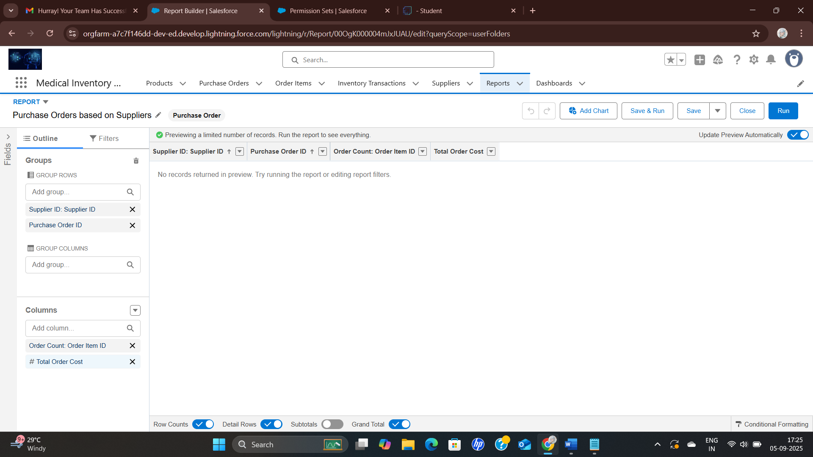

**\*Create a Complete Purchase Details Report**

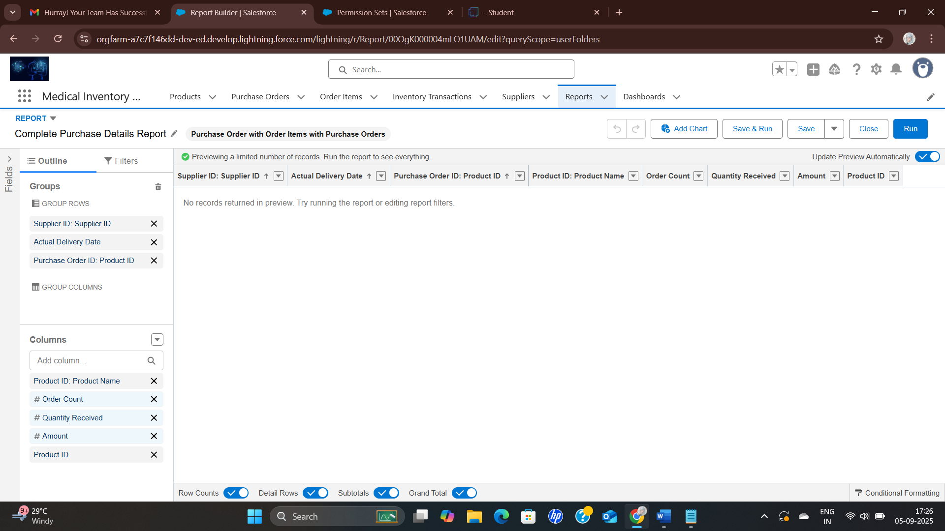

## Milestone 16 – Dashboards

### Create Dashboard

*Create Dashboard is Medical Inventory DashBoard

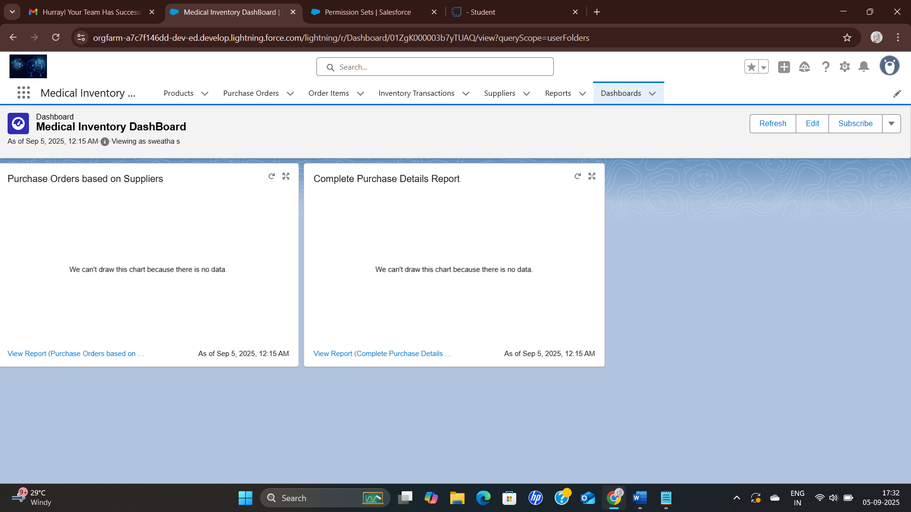

*Then insert the data in purchase orders based on suppliers and complete purchase details report.

# Conclusion:

A Medical Inventory Management System on Salesforce improves efficiency, accuracy, and accessibility of medical supplies management. While it requires investment and training, the benefits of automation, real-time tracking, and integration make it a valuable tool for healthcare organizations aiming to enhance patient care and reduce costs.